**PROJECT REPORT**

**ON**

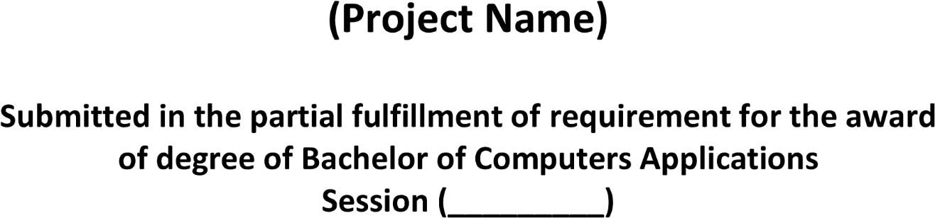

**2020-23**

**SwagZinn – A Social Media**

**2020 - 2023**

***Ms. Parull Bhardwaj***

***Assist. Professor***

***Vipul Kumar***

***20012041048***

